The University has replaced OxCORT with a new tutorial reporting system: TMS (Tutorial Management System). Using your SSO credentials, you can log in to TMS to set up teaching, submit (and approve) reports for your students, and make payment claims before the end of term. You may wish to save the URL for future use: tms.ox.ac.uk

Creating a College Teaching Arrangements (arranging tutorials / revision classes)
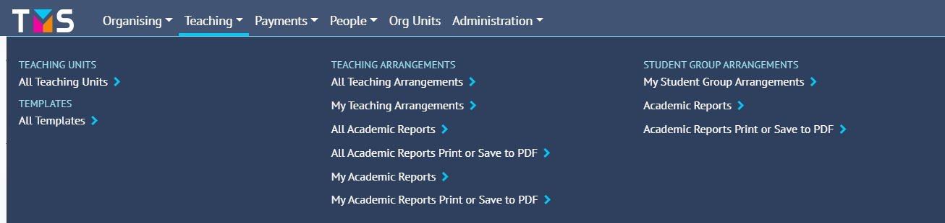
- Under the “Teaching” tab, select “My Teaching Arrangements”.

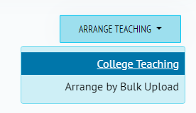
- Then select “Arrange Teaching” in the top right (a small blue button). You should then select “College Teaching” from that drop-down menu.

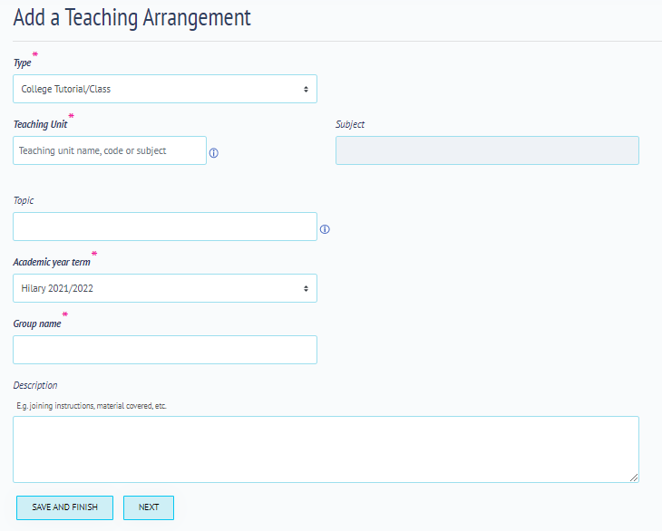
- Enter the “Teaching Unit” – the paper or module for which you are composing the reports. Use the key word search function to find the correct Unit, by the name, course code, or subject. The subject field will automatically populate.
Note: for cases where the teaching does not map neatly onto a specific element of / or a Programme of Study, it is also possible to choose ‘Subject not specified / Unit not specified’. In these cases you must add the “Topic”, and can specify what is being taught in the Description of a Teaching Arrangement.

- Enter the “Group Name”, so that you can identify the teaching group (e.g. Prelims Group 1).

- You may wish to add a brief description of the material covered – this may help to distinguish different groups within the same topic.
- Then click “Next”, at the bottom of the page, to add staff and students. The blank Teaching Arrangement will appear.

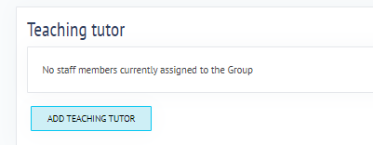
- Teaching tutor: there is only the option to add yourself as the assigned tutor. Click “Add Myself As Tutor” to assign yourself to the group; your name should appear in the Teaching Tutor box.
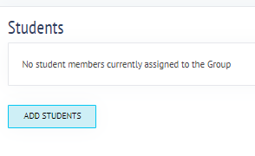
Organising tutor: select the option to “Add Teaching Tutor”. A list of tutors will appear; use the keyword search bar / combination of filters to search for a tutor. Select the tutor, then use the drop-down menu in the blue box (at the bottom of the page) to select their role. Then click “Add Tutors”. The new tutor (and role) will then appear in the Teaching Tutor box.
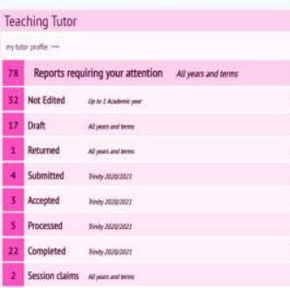
- Click “Add Students”. Use the keyword search bar and / or a combination of filters, on the left panel, to search for your students. If you are using the search bar, you must search by surname, SSO, or email. Select each student; the number of selected students will appear in the blue box at the bottom of the page. Then select “Add Students”, once all have been added. They will then appear in the “Students” section of the Teaching Arrangement.

- The created reports should then appear on your TMS homepage, under “Not Edited”.

The number of Teaching Arrangements that you have been assigned to will appear on your dashboard, on your TMS homepage.

You can click on the “Teaching” tab, under “My Teaching Arrangements” to navigate to your list of Teaching Arrangements, and complete your reports.
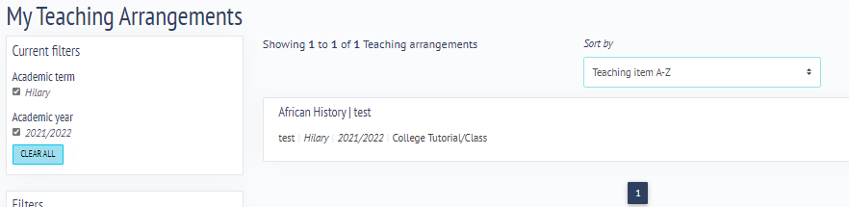

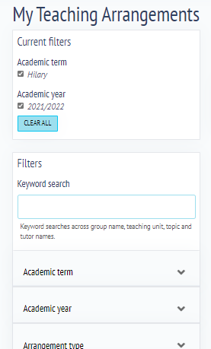
You can use the key word search bar, or the filters, to search for a particular Teaching Arrangement.

Completing and submitting termly reports
- Select the “Teaching Arrangements” row on your TMS dashboard (homepage).
- The Current Filters will default to the current term and academic year. Search for the relevant Teaching Arrangement, making sure you select the right Group (group name, academic year, and teaching type – displayed underneath the title). Click on the correct one.
- Select “Manage Hours”, which can be found by scrolling to the bottom of the page. This allows you to enter group sizes and hours. This is required for setting up a payment claim.
- Enter the combinations of group size and number of hours at the top of the page, and click the + icon. These will then be added to the student grid below. You may wish to add multiple groups to show different combinations of teaching groups.
- Use the pencil icon to edit the group size and hours. You can tick the relevant students within the group, to reflect the teaching that has been undertaken.
- Make sure you click the save icon (top of page) before continuing.
- Then click “Batch Edit” to start completing an academic report.
- The students within the teaching group appear in a list. Click on the student (this will highlight their name); select “Add End of Term Report”, at the top of the page.
- Complete the report, and then click Save. This will then be saved as a Draft – and can be accessed from our TMS dashboard at a later point, if necessary.
- A payment claim must be added before a report can be submitted. Click “Add Payment Claim”, underneath the report details. Select the appropriate Tutor Category and Payment Method for the claim, via the drop-down menus. Once all the information has been entered, click “Save”.
- The Bulk Hours information will appear on the right side of the page; you can edit this if necessary, and then select the payment rate from the drop-down menu. The click “Save”.
- Further edits to Payment Rate and Payment Method can be made by using the pencil icon.
Note: Tutor Comments, Payment Method, and Payment Rate must be saved before the “Submit” button appears.
- Click “Submit”; this will then be sent for approval.
Terminology
Though many of the functions within TMS are the same as those formerly in OxCORT, there are a couple of useful terms to know in advance:
Org Unit: this is the organisation name; this could be a College or Department, for which you are authorised to teach
Teaching Arrangement: the creation and management of teaching for a particular Teaching Unit or Topic, with tutors and students attached to it.
Teaching Unit: this represents the element of a Programme of Study (such as a paper or module)
Accepted: this is when an end-of-term report has been approved for processing.

